

**American International University- Bangladesh**

**CSC 2209: Object Oriented Programming 1 (JAVA)**

**CO1 Evaluation**

**Project Summary Report**

**Summer 18-19**

**Group No: 6**

**Project Title:** HOME MANAGEMENT SYSTEM

|  |  |
| --- | --- |
| Student Name | Student Id |
| Rafi, Md. Rafatur Raiyan | 17-34457-2 |
| Din Islam | 17-34936-2 |

**Introduction:**

*Write the answer of why you are doing this project?*

Whenever we think about renting a house or we want to give rent a house at first, we think about getting information as much as we can from a system. That’s where we need a home service management system. So, following this reason we create this system where owner can get all the information about the renters and renter also get the information about how much the rent payment and cost of utilities.

**User Category:**

There are three types of Users here. They are:

* Building Owner
* Renter

**Feature List:**

In this project the “Building owner” has the following features:

* Can access manage owner, renter info, renter balance.
* Search, insert, update, delete any renter or his information, balance.
* Get all renter id, name, job, Address, phone number from database table.

In this project the “Renter” has the following features:

* Can login into system.
* Get access to renter balance
* Cheque balance

**GUI Description:**

1. Login Window

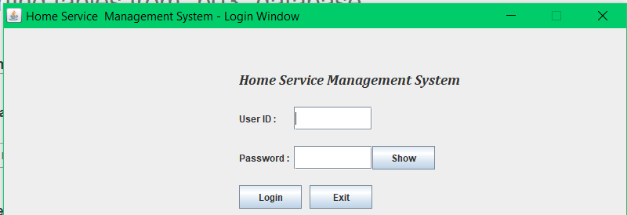

From this login frames user can login through verified password. From here user can go homepage portal. So here if user don’t put password correctly, they can’t access.

1. Owner home

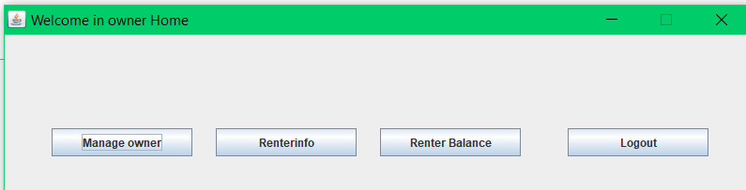

After login window owner came here to this frame and chose which frame he wants to go. But in terms of renter they can only get into Renter balance. From here if owner chose to go manage owner it will go to manage owner page.

1. Manage owner

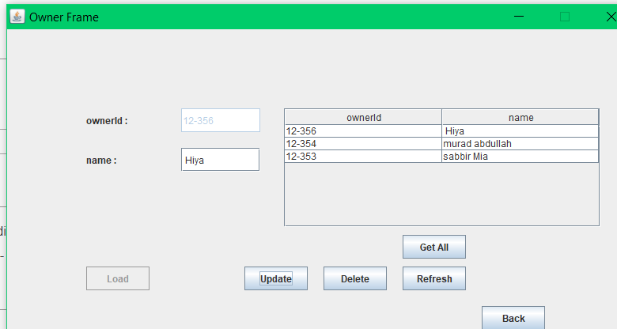

Here owner can find his information, also if owner want, he can change or update his information. Here also owner can go back to home page by click BACK button.

4. Renter Information

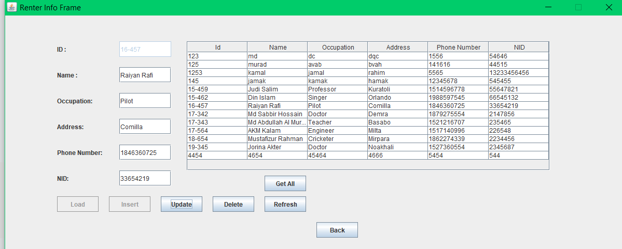

From home page owner can go to Renter info. Here owner can find all his renter information. Here owner can change or update or delete information. By pressing back button owner can go back to home page.

5.Renter Balance

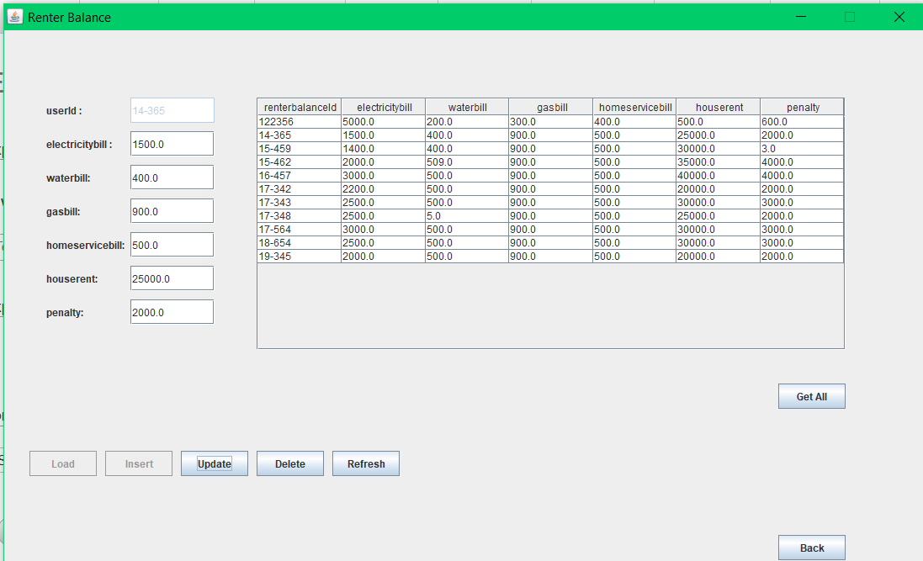

From home page owner and renter both can came to renter balance page. Here renter can check on their balance but renter can’t change anything here. But owner can update or added information here.

**Database Table Description:**

Table 1: Login

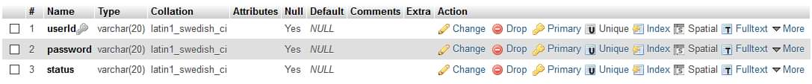

Table 2: Owner



Table 3: Renter balance

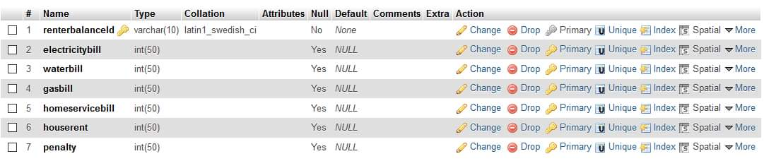

Table 4: renter info

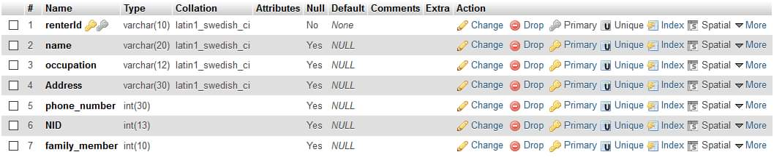

**Class Diagram:**

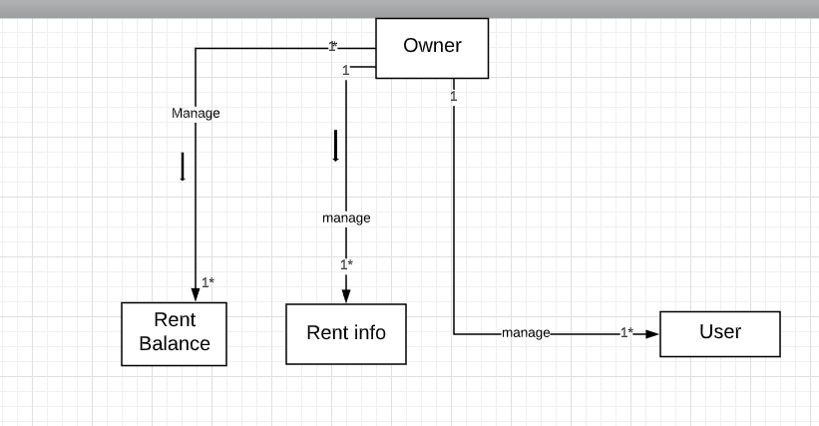

**Tools Used:**

To develop this project, we have used the following:

* Notepad++
* MY SQL
* Xampp
* Java8
* Jre
* Jdk

**OOP and Java Concepts Used:**

* Concept 1: Inheritance: inheritance is used here by extends classes from same and different packages.
* Concept 2: Encapsulation: Encapsulation is used here by using the access modifiers which are public, private, protected, package.
* Concept 3: Abstract method is use here.
* Concept 4: Interface concept is used by inherited another interface.
* Concept 5: Graphics User Interface (GUI) is used for creating GUI.
* Concept 6: Database connection and sql is used here for connecting with database for table data.

**Impact of this Project:**

What impact this project will have on the society and economy?

The purpose of this project is to monitor the house renting system, where owner can record the data and renter can get the information of house easily. Also, we added renter balanced on our system so it will record the renting payment and it will helpful for owner to pay the home tax properly in honest way.

How will people be benefited from your project?

At our project we try to create a system where renter and owner can get the clear idea of house renting system, so that there had no chance of misunderstanding between them. Because sometimes without proper management system can trigger problem between owner and renter, so if there has a perfect management system it can solve problem easily.

(Maximum 80 words)

**Limitations and Possible Future Improvements:**

We started our project with a big ambition but because of short timing we couldn’t finished it as we expected. But we did our best to run this project well enough. In future if we get enough time, we can improve our project as we expect.

In future we can add more feature like we can upgrade it to online so that renter can access from anywhere at any time. Also, they can pay rent through online banking by using our system.